🔹 Assignment 1: Permanent Table
Goal: Test persistence, Time Travel & recovery
Tasks:
- Create a permanent table EMP_PERM
create table EMP_PERM(
ID int,
Name varchar(20),
Course varchar(20),
Score int
);
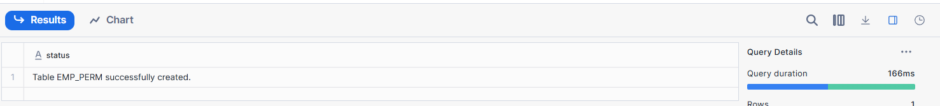
- Insert minimum 5 records
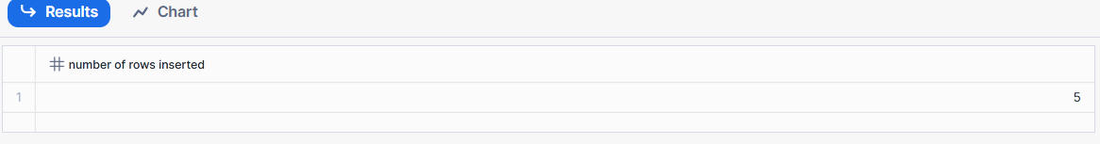
- Logout and login again
- Verify data persists
select * from EMP_PERM;
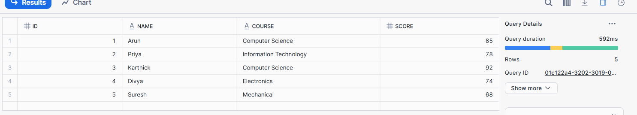
- Delete 2 records
delete from EMP_PERM where course = ‘Computer Science’
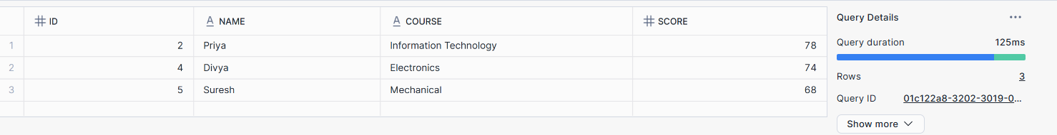
- Query deleted data using Time Travel
select * from EMP_PERM at (OFFSET => -1000);
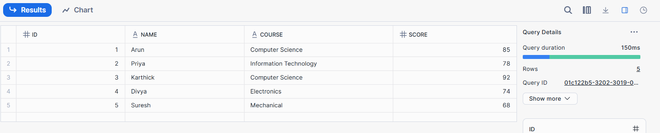
- Restore deleted data
insert into EMP_PERM
select * from EMP_PERM
at (OFFSET => -1000);
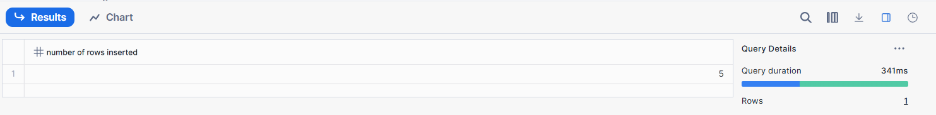
- Drop the table
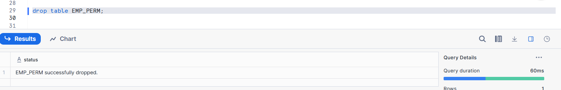
- Recover using UNDROP TABLE
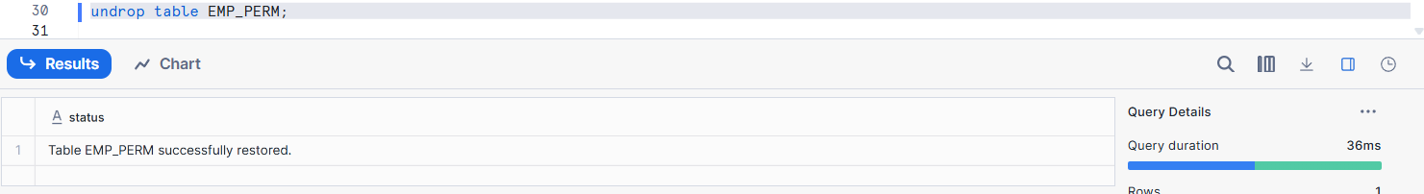
Learning Outcome:
✔ Data persists across sessions
✔ Supports Time Travel & Fail-safe

🔹 Assignment 2: Temporary Table
Goal: Test session-based background cleanup
Tasks:
- Create temporary table EMP_TEMP
CREATE TEMPORARY TABLE EMP_TEMP (
ID INT,
Name VARCHAR(20),
Course VARCHAR(30),
Score INT
);
- Insert records
insert into EMP_TEMP (id,name,course,score)
values(1,'Arun','Computer Science',85),
(2,'Priya','Information Technology',78),
(3,'Karthick','Computer Science',92),
(4,'Divya','Electronics',74),
(5,'Suresh','Mechanical',68);
- Query data successfully
select * from EMP_TEMP;
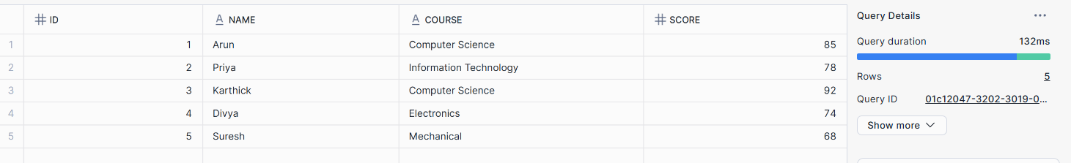
- End the session
Sign Out from snowflake .
- Reconnect and query the table
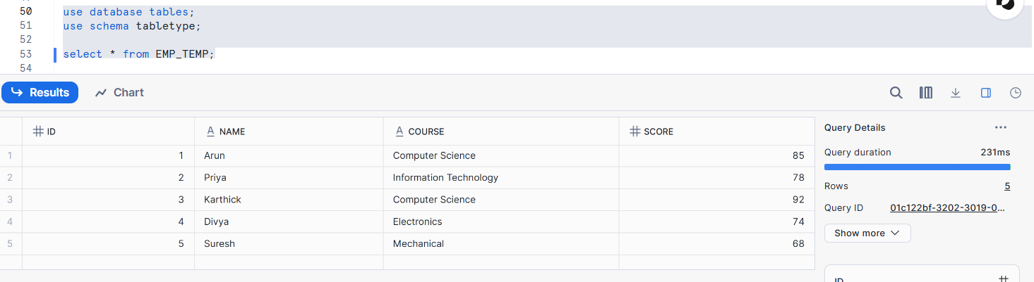
Learning Outcome:
✔ Table automatically removed after session ends
✔ No Time Travel or Fail-safe

🔹 Assignment 3: Transient Table
Goal: Test limited retention behavior
Tasks:
- Create transient table EMP_TRANS
CREATE TRANSIENT TABLE EMP_TRANS (
ID INT,
Name VARCHAR(20),
Course VARCHAR(30),
Score INT
);
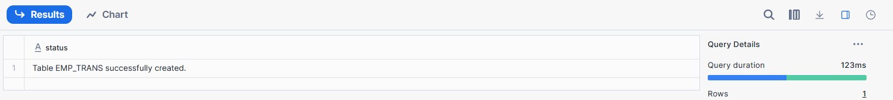
- Insert records
INSERT INTO EMP_TRANS (ID, Name, Course, Score)
VALUES
(1, 'Arun', 'Computer Science', 85),
(2, 'Priya', 'Information Technology', 78),
(3, 'Karthick', 'Computer Science', 92);
- Delete records
DELETE FROM EMP_TRANS
WHERE ID = 2;
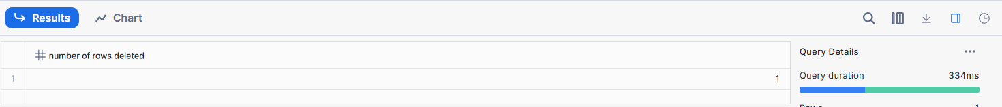
- Query data using Time Travel (within retention)
SELECT * FROM EMP_TRANS
AT (OFFSET => -15);
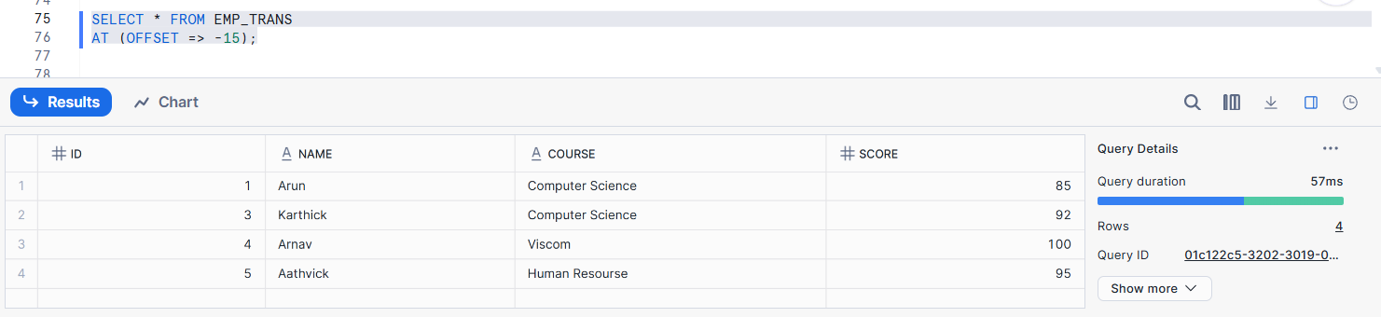
- Drop the table
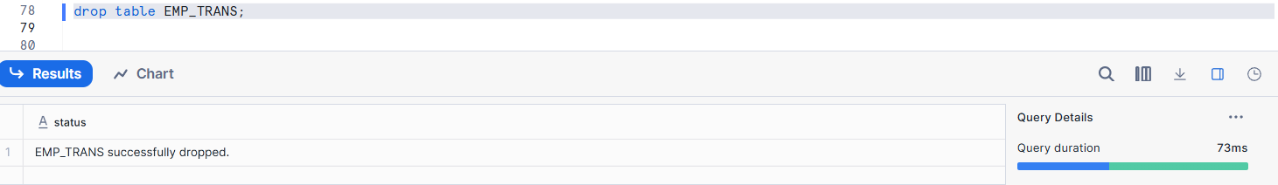
- Attempt recovery after retention period
Learning Outcome:
✔ Limited Time Travel
✔ No Fail-safe
✔ Faster background purge

🔹 Assignment 4: CTAS (Create Table As Select)
Goal: Test background data transformation
Tasks:
- Create table EMP_HIGH_SALARY using CTAS
create table EMP_HIGH_SALARY as
select * from EMP_TRANS
- Filter salary > 70,000
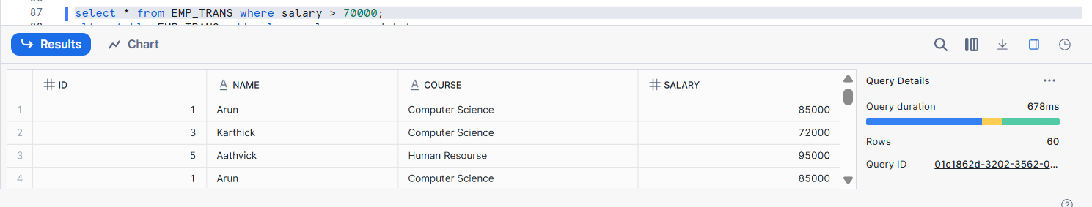
- Add calculated column SALARY_GRADE
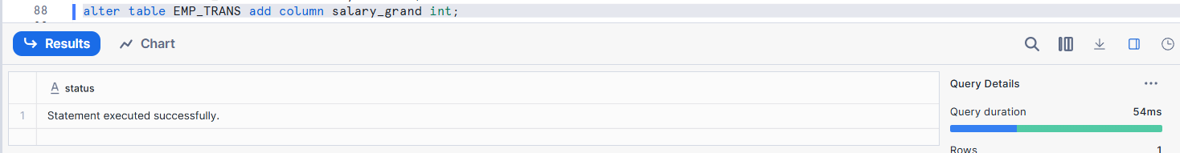
- Drop source table
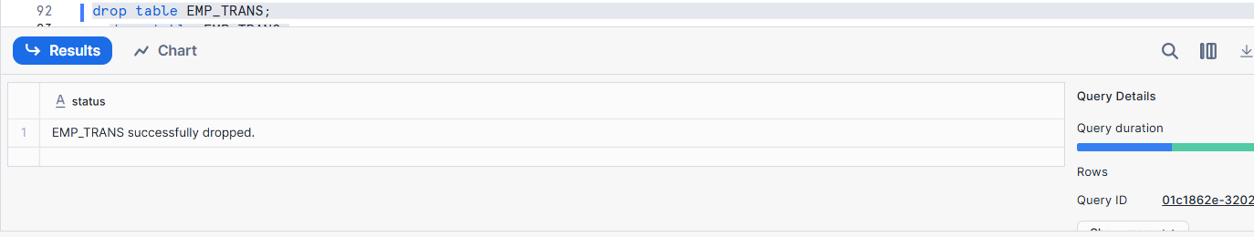
- Verify CTAS table still exists
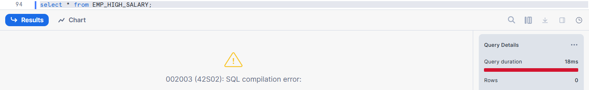
Learning Outcome:
✔ Independent table creation
✔ Background transformation execution

🔹 Assignment 5: Table Cloning
Goal: Test zero-copy cloning
Tasks:
- Clone EMP_PERM as EMP_CLONE
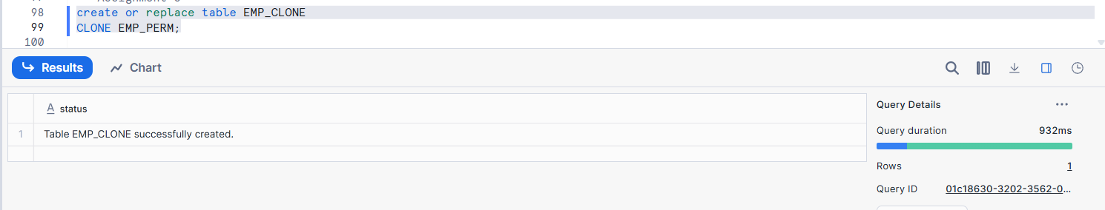
- Update data in cloned table
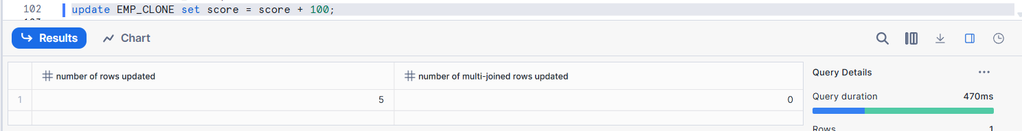
- Compare original vs clone
Original Table :
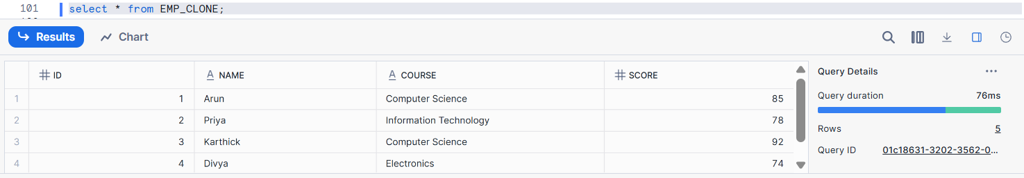
Cloned Table :
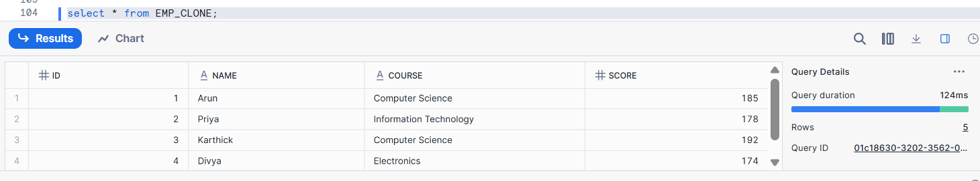
- Explain storage behavior
Storage behaviour describes how a system saves, manages, and frees data over time.
It defines what happens to data when records are created, updated, deleted, or retained, including limits, retention, and recovery rules.
Learning Outcome:
✔ Zero-copy storage
✔ Independent data modification

🔹 Assignment 6: Time Travel Testing
Goal: Test point-in-time recovery
Tasks:
- Perform DELETE on any table
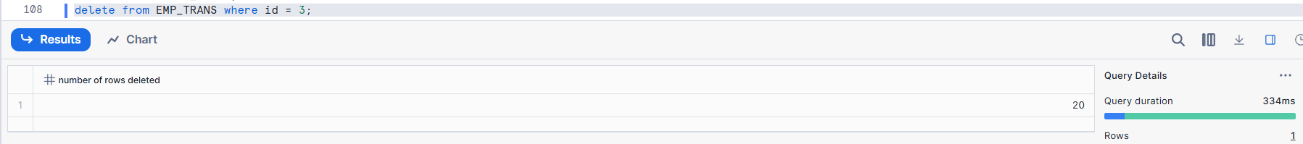
- Query using:
  - AT OFFSET
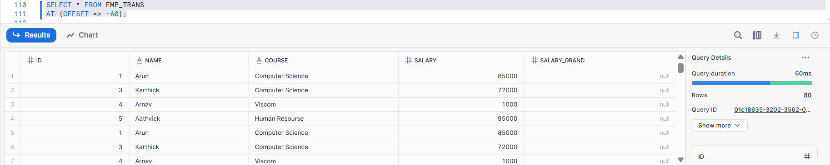
  - AT TIMESTAMP
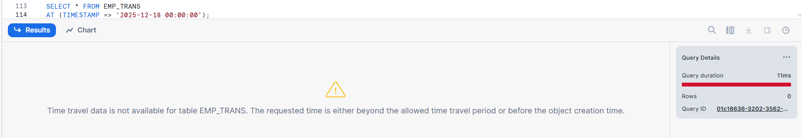
- Restore deleted data

Learning Outcome:
✔ Background versioning
✔ Point-in-time recovery

🔹 Assignment 7: Drop & Purge Behavior
Goal: Compare cleanup rules
Tasks:
- Drop Permanent table and recover it
Drop Table:
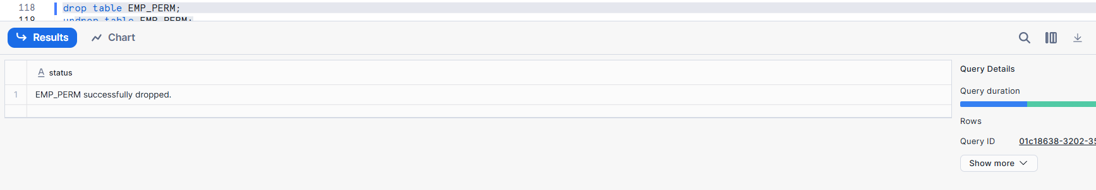
Undrop Table:
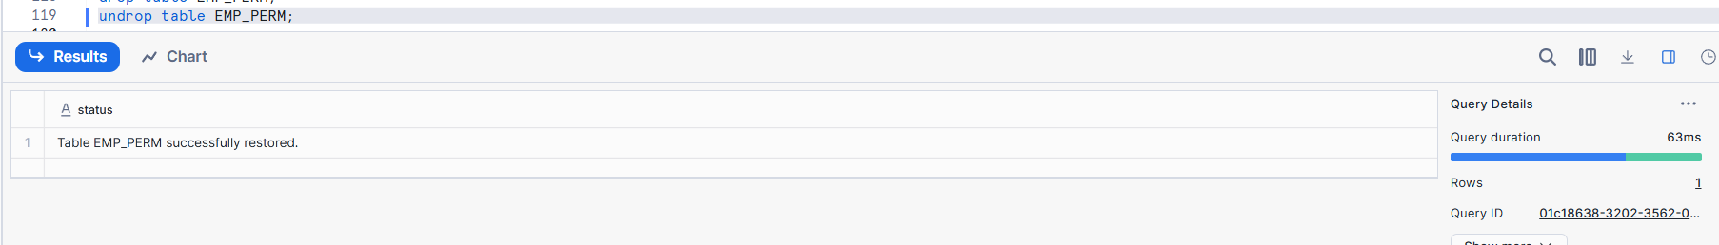
- Drop Transient table and attempt recovery
Drop Table:
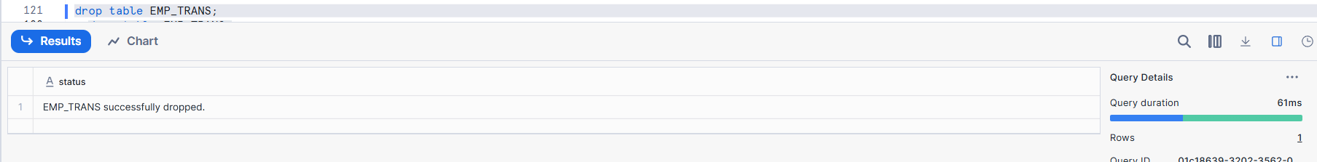
Undrop Table:
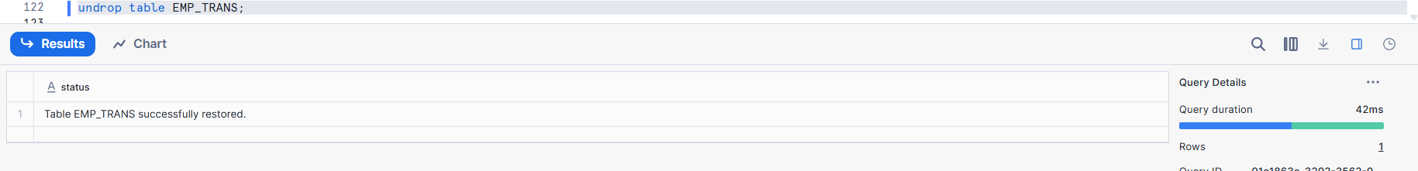
- Drop Temporary table and verify immediate removal
Drop Table:
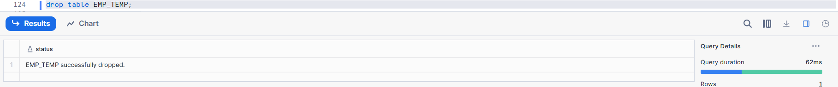
Verify immediate removal :
OLD SESSION:
NEW SESSION:
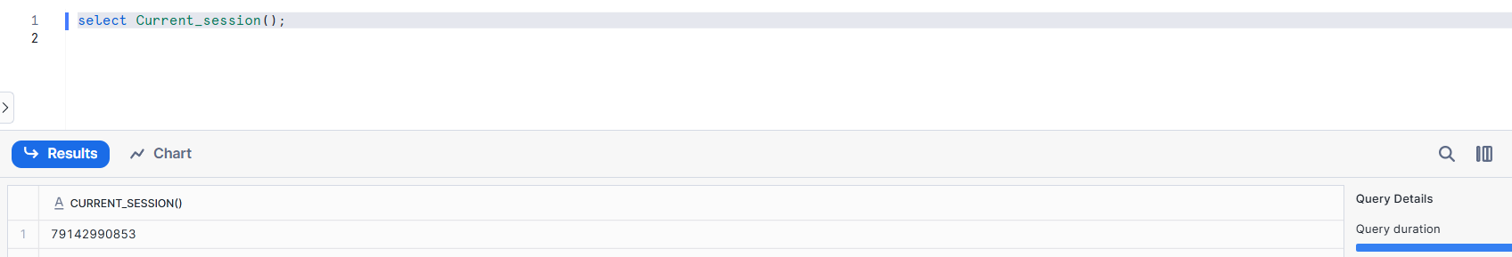
Final:
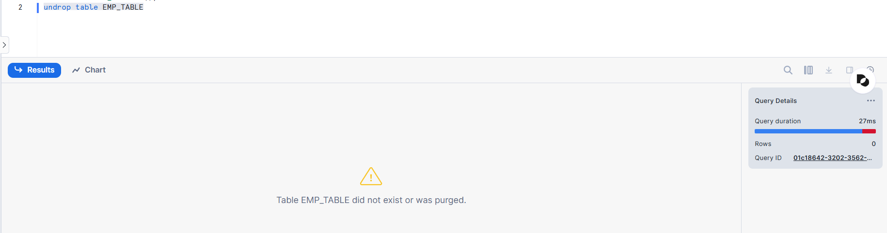
Learning Outcome:
✔ Different purge behavior per table type

🔹 Assignment 8: External Tables
Goal: Query data stored outside Snowflake
Tasks:
- Create an external stage (S3 / ADLS / GCS)
- Create an external table on CSV or JSON data
- Query external table
- Add new file to external storage
- Refresh metadata and re-query
Questions to Answer:
- Does Snowflake store the data?
- Is Time Travel supported?
- What happens when source file is deleted?
Learning Outcome:
✔ Metadata-only tables
✔ No data storage inside Snowflake
✔ Manual metadata refresh

🔹 Assignment 9: Dynamic Tables
Goal: Test automated background refresh
Tasks:
- Create a source table SALES_RAW
- Insert sample sales data
- Create a Dynamic Table SALES_AGG_DT
  - Aggregate total sales by region
- Set refresh lag (e.g., 1 minute)
- Insert new data into SALES_RAW
- Observe automatic refresh
Questions to Answer:
- Is manual refresh required?
- How does refresh lag work?
- Difference between Dynamic Table and Task + Table?
Learning Outcome:
✔ Automatic background refresh
✔ Declarative transformation logic

🔹 Assignment 10: Comparison & Analysis
Goal: Conceptual understanding
Tasks:
Create a comparison table for:
- Permanent vs Temporary vs Transient
- Internal vs External Tables
- Static Tables vs Dynamic Tables
Include:
- Storage
- Time Travel
- Fail-safe
- Refresh behavior
- Use cases

📦 Student Deliverables
- SQL scripts
- Output screenshots
- Answers to conceptual questions
- Final comparison table

⏱️ Estimated Time
🕒 2 – 2.5 Hours

✅ Evaluation Criteria
- Correct execution: 40%
- Understanding of background behavior: 40%
- Explanation & documentation: 20%

